Title:
Source:
Problem:
0<= x <= 1, 0 <= y <= 1
min

subject to:
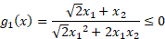

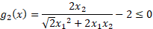
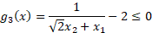

Optimal Value: n/a
Optimal Solution(s):
x= n/a , y= n/a
Edited by: YU-TING, LIN
Date: 1/15/2021

